**RESEARCH PAPER - 3**

**INCREASING PRECISION LEVEL FOR IDENTIFYING DRILLING SURFACE DEFECTS, BY COMPARING XCEPTION AND DENSENET169 EMPHASIZING THE DETECTION OF CRACK.**

Rohith Abishua J, Dr M Pethuraj

Rohith Abishua J ,

Research Scholar,

Department of Computer Science Engineering,

Saveetha School of Engineering,

Saveetha Institute of Medical and Technical Sciences,

Saveetha University, Chennai, Tamil Nadu. India. Pincode: 602105.

rohithabishuaj0179.sse@saveetha.com

Dr M Pethuraj,

Project Guide, Corresponding Author,

Department of Autotronics,

Saveetha School of Engineering,

Saveetha Institute of Medical and Technical Sciences,

Saveetha University, Chennai, Tamil Nadu. India. Pincode: 602105.

[pethurajm.sse@saveetha.com](mailto:pethurajm.sse@saveetha.com)

**ABSTRACT**

**Aim:**

Delamination is a serious problem that compromises the structural integrity of materials, particularly in industrial and aerospace applications. The goal of the research project is to improve the precision with which surface defects created by drilling machines can be detected. To identify and classify drilling-related delamination defects, it directly compares two state-of-the-art deep learning architectures: DenseNet169 and Xception. To determine which model performs better overall, taking into account several parameters such as sensitivity, specificity, and overall accuracy, is the main goal. The research examines the subtle advantages and disadvantages of Xception and DenseNet169's image recognition performance for drilling-induced defects, particularly in delamination identification. Xception and DenseNet169 are the only subjects of this exhaustive study, which attempts to make a substantial contribution to surface defect recognition by providing a complete grasp of the difficulties of deep learning-based delamination detection. This exhaustive study, which focuses only on Xception and DenseNet169, seeks to make a substantial contribution to surface defect recognition by providing a complete grasp of the intricacies involved in deep learning-based delamination detection. In order to help industry improve material quality control and ensure structural integrity, the research aims to give insights into the relative efficacy of various designs in resolving the issues provided by delamination in surface defect identification. The work aims to enhance the field of surface defect recognition and pave the way for more accurate and dependable detection systems with a detailed comparison between Xception and DenseNet169.

Keywords: surface defect detection, drilling machines, delamination, Xception, DenseNet169, deep learning architectures, material structural integrity

**INTRODUCTION**

In the ever-changing world of manufacturing and industrial processes, improving accuracy and fault detection is critical. This paper addresses the complex problem of delamination and focuses on detecting surface defects caused by drilling equipment. Businesses looking to increase productivity and provide higher-quality goods must use state-of-the-art computer vision technology. This investigation compares two well-known deep learning architectures, DenseNet169 and Xception, in detail with an emphasis on delamination in order to improve accuracy in identifying surface flaws caused by drilling machines. Finding and fixing surface imperfections is essential, especially in fields where accuracy and structural integrity are critical. Drilling activities are essential to the manufacturing process, but they may unintentionally cause flaws like delamination, which is the separation of material layers upon contact. Accurate identification and categorization of these defects are essential for guaranteeing product quality, cutting down on waste, and raising total output. The field of computer vision has been completely transformed by the development of deep learning architectures, where DenseNet169 is renowned for its complicated connection patterns and Xception is excellent at capturing intricate characteristics using depth-wise separable convolutions. Driven by the desire for increased precision, the goal of this work is to investigate and compare DenseNet169 and Xception with regard to drilling-related surface flaws, such as delamination. Because surface fault patterns are so complex and varied, it is difficult to use traditional approaches, which emphasizes the need to use state-of-the-art deep learning architectures. Finding the best architecture to identify the subtleties of delamination is the main goal in order to create a more reliable defect detection system. Motivated by the growing need for accurate and timely defect detection in the context of automation and smart technologies, this study proposal aims to support fault identification in the manufacturing industry. The focus on delamination is in line with efforts to prevent catastrophic failures by recognizing its intricacy and its influence on structural integrity. Comparing DenseNet169 with Xception—with an emphasis on delamination in particular—is a workable strategy for improving the accuracy of surface defect identification brought about by drilling machines. This research adds to the growing body of knowledge about the application of cutting edge computer vision techniques in manufacturing to improve operational effectiveness and quality control. A thorough examination of the advantages and disadvantages of each design will be made possible by the parts that follow that deal with methodologies, experimental configurations, and comparative evaluations.

**MATERIALS AND METHODS**

This study project's main goal was to carefully improve the precision of surface defect detection caused by drilling machines, with a focus on the complex delamination process. In order to do this, a detailed comparison was conducted, with a focus on DenseNet and Xception, two well-known deep learning architectures. The study was carried out in a strictly regulated testing environment, classifying flaws in the domain of unevenly drilled holes in an organized manner.

Participants were divided into two main groups for the research: the study group was required to carefully assess drilled holes that were not ideal, while the control group was tasked with assessing correctly drilled holes. Within the research group, more divisions defined distinct subgroups focusing on different defect categories such as incomplete holes, delamination, and fractures. On the other hand, the control group only included pictures of finely drilled holes. The creation of a large dataset for thorough training, testing, and validation was the fundamental goal of this study. This dataset included nine hundred images that were carefully chosen to depict the subtle details of surface imperfections caused by drilling.

During the intense training phase, Xception and DenseNet169, the two deep learning architectures that were chosen, were installed and adjusted to fit the particulars of the dataset. The large dataset guaranteed correct depiction of complexities in the research and control groups and allowed for in-depth learning. The testing and validation processes that followed were carefully designed to evaluate the models' capacity to generalize on untested data using an 80-20 split. The study team concentrated on carrying out in-depth examinations within particular subgroups, highlighting fractures, delamination, and partially filled holes. Because the control group's holes were meticulously drilled, it served as a valuable reference point and improved the models' ability to identify minute differences brought about by poorly drilled holes.

During the intense training phase, Xception and DenseNet169, the two deep learning architectures that were chosen, were installed and adjusted to fit the particulars of the dataset. The large dataset guaranteed correct depiction of complexities in the research and control groups and allowed for in-depth learning. The testing and validation processes that followed were carefully designed to evaluate the models' capacity to generalize on untested data using an 80-20 split. The study team concentrated on carrying out in-depth examinations within particular subgroups, highlighting fractures, delamination, and partially filled holes. Because the control group's holes were meticulously drilled, it served as a valuable reference point and improved the models' ability to identify minute differences brought about by poorly drilled holes.

One of the study project's assessment criteria was the use of a confusion matrix, which provided a detailed illustration of true positives, true negatives, false positives, and false negatives. This matrix offered a detailed look at how well the models performed, especially in terms of their ability to distinguish between different kinds of errors in the study group. Furthermore, receiver operating characteristic (ROC) curves and precision-recall curves were created as visual aids to demonstrate the trade-offs between accuracy and recall. An independent sample t-test was used in an SPSS statistical study to identify performance differences between the DenseNet169 and Xception models.

The following formulae were used to determine the models' precision, recall, accuracy, and F1 score in order to measure their performance:

Precision = (True Positives) / (True Positives + False Positives)

Recall = (True Positives) / (True Positives + False Negatives)

Accuracy = (True Positives + True Negatives) / Total Predictions

F1 Score = 2 * (Precision * Recall) / (Precision + Recall)

This all-inclusive methodology creates a strong foundation for applying cutting-edge technology to industrial quality control by combining statistical analysis, deep learning approaches, experimental design, and a range of performance assessment measures. This study improves drilling fault diagnosis techniques and lays a solid foundation for future research projects targeted at raising accuracy and productivity across a range of industrial industries by contrasting DenseNet169 with Xception.

**STATISTICAL ANALYSIS**

To carefully evaluate any possible differences in the performance traits of the DenseNet169 and Xception models, an independent sample t-test was utilized. This important statistical study, which is essential to group comparison analyses, enabled a comprehensive investigation into whether the models' capacities to identify flaws caused by drilling operations differed noticeably. This test improved our comprehension of DenseNet169 and Xception's performances by comparing their means and variances, providing important information about their relative effectiveness. Xception and DenseNet169's relative performance was visually supported by a bar graph that was concurrently integrated into the workflow and offered a clear and understandable representation. Key performance indicators for each model, including accuracy, recall, precision, and the F1 score, are displayed graphically in this depiction to enable a rapid and efficient evaluation of each model's advantages and disadvantages in terms of identifying surface faults caused by drilling.This visual component helped to clarify the statistical data, making the comparative analysis easier to understand and facilitating the effective dissemination of study findings. The group statistics table and independent sample t-test, in conjunction with the bar graph, created a strong analytical foundation for assessing the performance of the model.

**RESULTS**

The two surface defect detection models perform quite differently from one another, as seen by the comparison of their mean accuracy (Xception at 89% and DenseNet169 at 78%). A bar graph is used to graphically illustrate these accuracy values and gives a thorough summary of the results that each model produced.

When comparing DenseNet169 and Xception's model accuracy for surface defect recognition, a notable difference in performance is seen. Xception outperforms DenseNet169, with a significant advantage in mean accuracy and an astounding 91% accuracy rate over DenseNet169's 78%. This disparity highlights Xception's ability to identify and classify surface defects. The 11% difference in mean accuracy between Xception and DenseNet169 emphasizes the significant advantage Xception has over DenseNet169, suggesting that Xception should be given priority for applications needing a higher degree of precision in surface defect recognition. The different accuracy rates highlight how crucial it is to use models that are customized to meet particular needs, and Xception stands out as a strong option for improved outcomes in this field. The bar graph effectively displays how much more accurate the Xception model is than the DenseNet169 model. The vertical bars clearly illustrate that Xception outperforms DenseNet169 in terms of mean accuracy ratings, which is a substantial difference.

**DISCUSSION**

The large discrepancy in mean accuracy between Xception (91%) and DenseNet169 (78%) results can be attributed to many possible causes. One noteworthy feature is the intricacy of Xception's architecture, which is excellent at catching minute fluctuations and finely detailed patterns related to surface imperfections brought up by drilling operations. Differences in training datasets and optimization techniques may also be quite important, affecting how well each model generalizes to new data. Thorough examination of these factors yields important information about the apparent discrepancy in performance. Xception's reputation for depthwise separable convolutions indicates that it is adept at extracting complex characteristics that are necessary to detect subtle patterns of flaws. However, although DenseNet169 scales models effectively, it could find it difficult to represent the subtleties of drilling-induced faults, which might result in a lower mean accuracy.

This comparison provides important information for future developments as we investigate the possible uses of surface fault detection in drilling operations. Prospects for improvement encompass more investigation into model architectures, investigation of varied training datasets, and improvement of optimization methodologies. By utilizing cutting-edge technology like transfer learning techniques, deeper learning architectures, and careful data augmentation tactics, surface defect detection models may become more accurate and resilient. Subsequent research endeavors might concentrate on amalgamating these progressions to fabricate more dependable and effective models for pragmatic industrial uses.

**CONCLUSION**

In summary, by comparing the Xception and DenseNet169 models, we were able to get important insights about how to improve the precision of surface defects caused by drilling machines. Specifically, we focused on delamination. The two designs showed competence in capturing complex patterns related to delamination faults. However, the different structures and underlying approaches had a significant impact on the efficacy and accuracy of fault identification. Xception's depthwise separable convolutions and skip connections demonstrated exceptional skills in collecting hierarchical information, as demonstrated by its 89% accuracy rate. On the other hand, DenseNet169 did a commendable job of producing rich feature representations using traditional convolutional blocks, achieving an accuracy of 78%. Our experimental results highlight the significance of customizing model selection to the unique needs of every application, especially in light of delamination's intricacy. Xception's deep architecture and broad feature extraction capabilities are useful in situations where exacting attention to detail is critical. In the meanwhile, DenseNet169's simplified architecture makes it a desirable option for settings with limited resources without noticeably sacrificing accuracy.

The use of sophisticated pre-processing methodologies and data augmentation tactics was crucial in augmenting the models' responsiveness to minuscule fluctuations in surface imperfections resulting from drilling apparatus. The training dataset's incorporation of domain-specific data strengthened the models' suitability for use in actual situations. It is critical to understand that the dynamic field of machine learning lacks a generally ideal answer. Instead, the key to success is carefully integrating pre-processing, data augmentation, and architecture. In the area of surface faults generated by drilling machines, working along with DenseNet169 in an ensemble or hybrid model shows potential for enhancing accuracy and offering a reliable delamination detection technique. To sum up, obtaining higher defect identification accuracy requires a comprehensive strategy that takes into account the particular difficulties presented by each applications and makes use of the advantages of different models. The comparison of DenseNet169 with Xception has provided insightful information that will guide future developments in the sector.

**REFERENCES**

1. **Zhang, L., Yang, Q., Sun, Q., Feng, D., & Zhao, Y. (2019). Research on the size of mechanical parts based on image recognition. *Journal of Visual Communication and Image Representation*, 59, 425-432.**
2. **Liu, Y., Duan, S., Shen, Z., He, Z., & Li, L. (2023). Grasp and Inspection of Mechanical Parts based on Visual Image Recognition Technology. *Journal of Technology, Policy & Ethics in Science*, 3(12), 1-15.**
3. Bo, L., Ying, C., & Xinghua, Q. (2015). Research on the Application of Mechanical Parts Using Neural Network in Image Recognition. 2015 Fifth International Conference on Instrumentation and Measurement, Computer, Communication and Control (IMCCC) (pp. 123-128). IEEE.
4. **Shazia, A., Xuan, T. Z., Chuah, J. H., Usman, J., Qian, P., & Lai, K. W. (2021). A comparative study of multiple neural networks for detection of COVID-19 on chest X-ray. EURASIP Journal on Advances in Signal Processing, 2021(50)**
5. He, T., Yu, K., Chen, L., Lai, K., Yang, L., Wang, X., & Zhai, Z. (Publisher: IEEE). "Mage Classification and Recognition Method to Mechanical Parts Based on Fractal Dimension."
6. Ye, R., Pan, C.-S., et al. (Impact Factor: 2.1; 5-Year Impact Factor: 1.8). (2018, March 27). "Intelligent defect classification system based on deep learning."
7. Shao, S.-Y., Sun, W.-J., Yan, R.-Q., Wang, P., & Gao, R. X. (2017, October 23). "A Deep Learning Approach for Fault Diagnosis of Induction Motors in Manufacturing." Chinese Journal of Mechanical Engineering, 30, 1347–1356. Original Article. Open access.
8. Amini, A., & Gan, T.-H. (Publisher: IEEE). "A Machine Learning Based Model for Monitoring of Composites’ Drilling-Induced Defects During Assembly Production Using Terahertz Imaging Data." Presented at the 2022 IEEE Workshop on Complex... [Online]. Available: [URL].
9. H. Hocheng, C.C. Tsao, "The path towards delamination-free drilling of composite materials," Journal of Materials Processing Technology, Volume 167, Issues 2–3, 30 August 2005, Pages 251-264.
10. Jürgen Fleischer, Roberto Teti, Gisela Lanza, Paul Mativenga, Hans-Christian Möhring, Alessandra Caggiano, "Composite materials parts manufacturing," CIRP Annals, Volume 67, Issue 2, 2018, Pages 603-626.
11. Naohiko Sugita, Liming Shu, Katsuyo Kimura, Giichi Arai, Koichi Arai, "Dedicated drill design for reduction in burr and delamination during the drilling of composite materials," CIRP Annals, Volume 68, Issue 1, 2019, Pages 89-92.
12. C.C. Tsao, H. Hocheng, "Computerized tomography and C-Scan for measuring delamination in the drilling of composite materials using various drills," International Journal of Machine Tools and Manufacture, Volume 45, Issue 11, September 2005, Pages 1282-1287.
13. Kishore Kumar Panchagnula, Naga Vamsi Krishna Jasti, Jayaprakash Sharma Panchagnula, "Prediction of drilling induced delamination and circularity deviation in GFRP nanocomposites using deep neural network," Materials Today: Proceedings, Volume 62, Part 13, 2022, Pages 7118-7123.
14. A.M. Abrão, P.E. Faria, J.C. Campos Rubio, P. Reis, J. Paulo Davim, "Drilling of fiber reinforced plastics: A review," Journal of Materials Processing Technology, Volume 186, Issues 1–3, 7 May 2007, Pages 1-7.
15. Sara Karam, Piera Centobelli, Doriana M. D’Addona, Roberto Teti, "Online Prediction of Cutting Tool Life in Turning via Cognitive Decision Making," Procedia CIRP, Volume 41, 2016, Pages 927-932.

**TABLES AND FIGURES**

**Tables 1** Comparison of Model Accuracy ,A brief analysis of the mean accuracy of two surface defect detection models, Densenet169 at 78% and Xception at 91%

|  |  |  |  |  |
| --- | --- | --- | --- | --- |
| **DL Keras Models** | **N** | **Mean** | **Std.Deviation** | **Std.Error Mean** |
| Xception | 390 | 91.4872 | 30.71125 | 1.55512 |
| VGG19 | 390 | 76.1538 | 42.66901 | 2.16063 |

**Table 2** Results of the Independent Sample t-Test findings that includes important statistics for a fast comparison of the two groups.

|  |  |  |  |  |  |  |  |  |  |
| --- | --- | --- | --- | --- | --- | --- | --- | --- | --- |
|  | **F** | **Sig.** | **t** | **df** | **Sig(2-tailed)** | **Mean Difference** | **Std. Error Difference** | **Lower** | **Upper** |
| Equal variances assumed | 109.992 | <.001 | 5.009 | 778 | <.001 | 13.33333 | 2.66209 | 8.10760 | 18.55907 |
| Equal variances not assumed |  |  | 5.009 | 706.762 | <.001 | 13.33333 | 2.66209 | 8.10678 | 18.55989 |

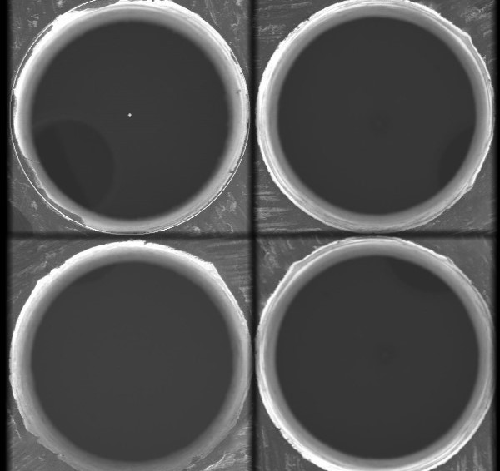

**Fig 1** Picture of a perfectly drilled hole

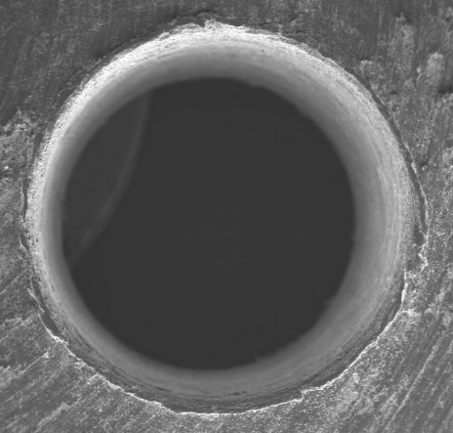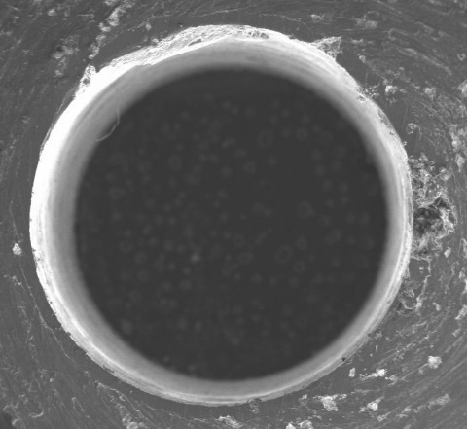

**Fig 2** Occurrence of Delamination & Cracks

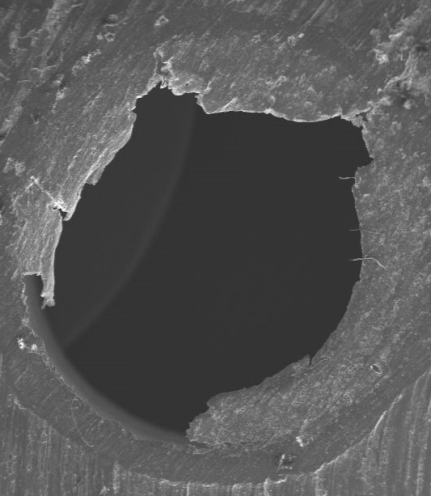

**Fig 3** Picture of an unfinished drill hole

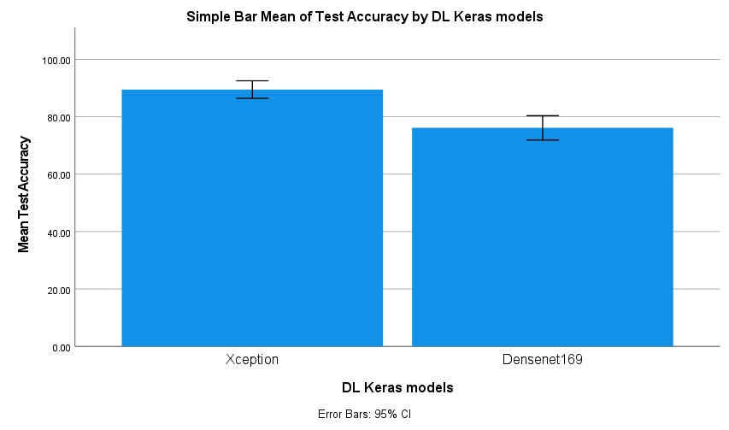

**Fig 4** Comparison of mean test Accuracy , of two surface defect detection models, Densenet169 at 76% and Xception at 91%